1. A screenshot of a website

   Description automatically generated
2. 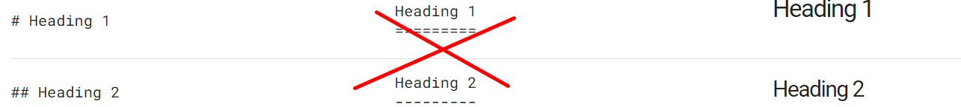
3. 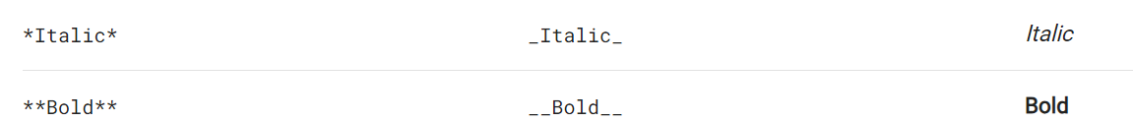  
   Three asterisk marks for bold and italic together.
4. A close up of a website

   Description automatically generated
5. A close-up of a screen

   Description automatically generated
6. A screenshot of a computer

   Description automatically generated
7. 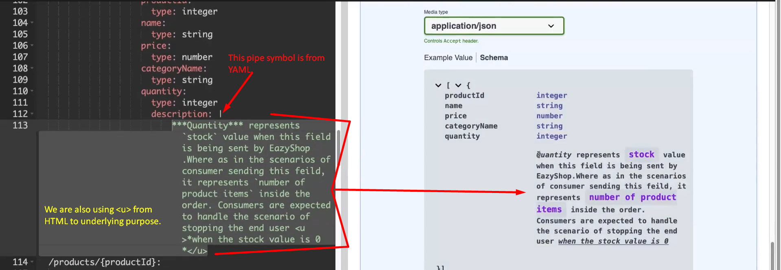
8. We will put this description for quantity wherever there is quantity property.